Android Design Documentation

What will the user see when they launch the app for the first time?
- Tutorial fragment

Login Screen / Registration Screen

Main view after successful login

(tile scheme example)
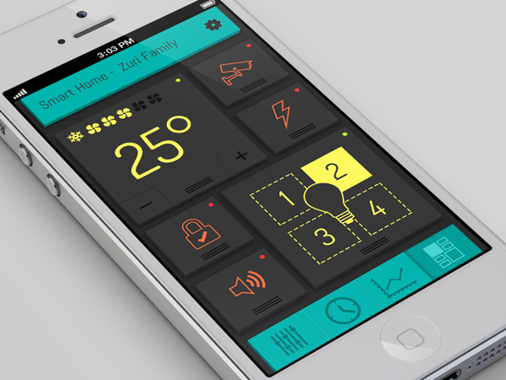

“Friends” list example
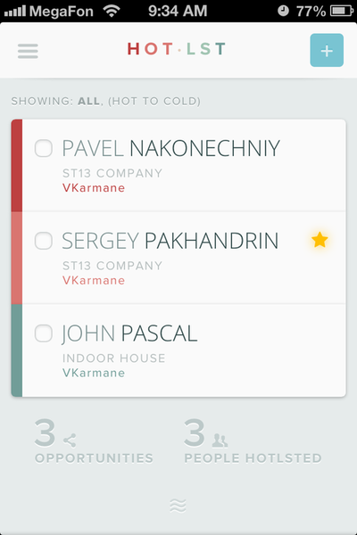

Menu Navigation example
